9.12.13 [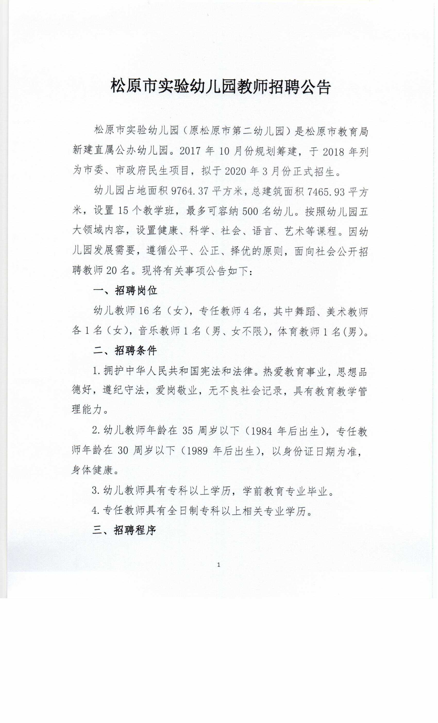](http://jy.jlsy.gov.cn/jyzt/201912/W020191213369462768821.jpg)

[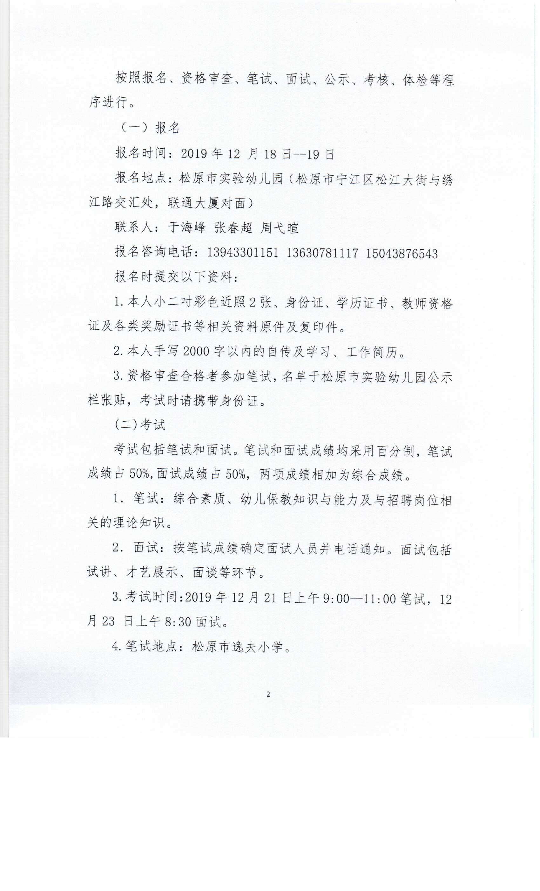](http://jy.jlsy.gov.cn/jyzt/201912/W020191213369462767163.jpg)

[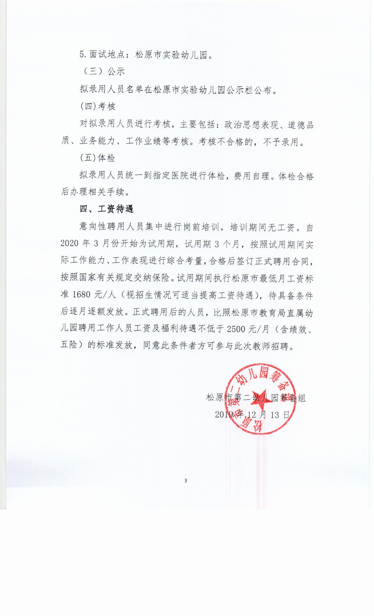](http://jy.jlsy.gov.cn/jyzt/201912/W020191213369462770873.jpg)